Lab 4 Documentation – Justin Pham
- Lab4 was built out of our Lab2 that focused on RSA and AES. The design process mainly had to do with sending and receiving message responses between our client.py and server.py. I was able to get steps 1-5 working properly and print all values between the interactions between the client.py and server.py but had an issue with decoding my bytes based on my AES files and was not sure how to fix that problem to continue. I wasn’t too sure on how to setup .pem files so I did the lab without creating and reading .pems. I also haven’t set up req and data yet for the hardcoded values. I also ran out of time to add more comments and implement steps 7 even if step 6 will not work for me.
I took a lot of the approaches of sending and receiving from lab3.
- I was able to check if the server-id meets a mismatch. It’ll tell you that there is a mismatch within the server.
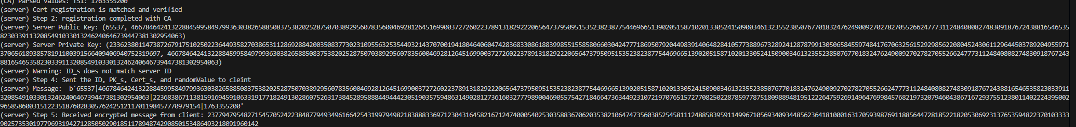

Outputs: On my demo, there is only outputs for steps 1-5 as step 6 doesn’t work, I’ve commented out the functions for step 6
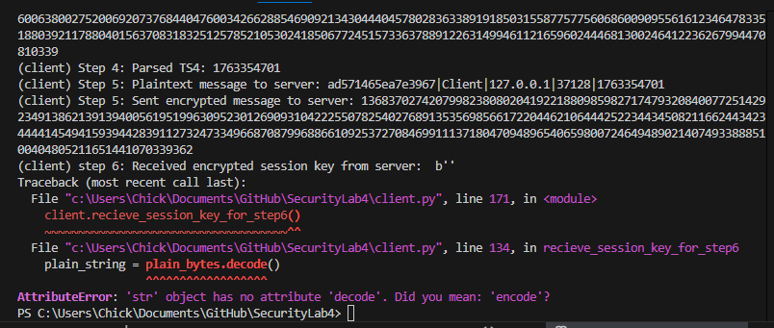

Outputs: left side is server.py output and right side is client.py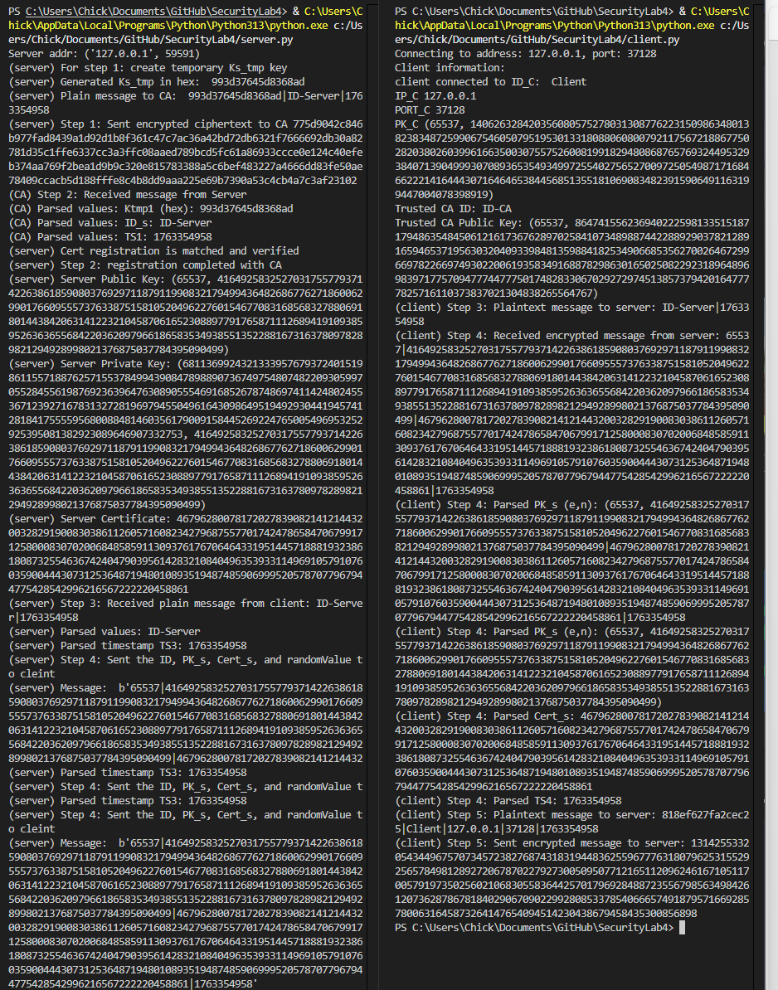
Step 5 output remains:
